Module 1 – Basic Config

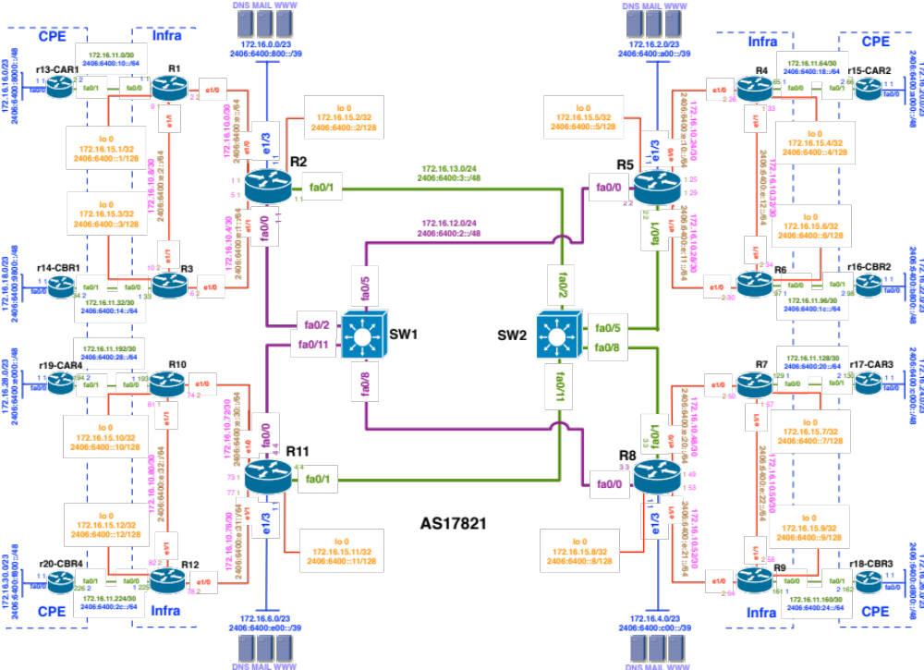

- The topology shows 4 regional networks comprised of a core POP and 2 aggregation POPs (edge routers).
- Edge routers aggregate downstream customers.
- The regional networks are interconnected with redundant transport links.

Lab Tasks

Participants should complete the following tasks for this module:
- Base best practice configuration
- Interface address (IPv4/v6) configuration
- Verify reachability of directly connected interfaces

Lab Exercise

- Basic best practice Configuration:

Example Config on a R1:

config t

To enter into a cisco router global configuration mode.

hostname R1

configure the hostname

ipv6 unicast-routing

Enable IPv6 routing

ip cef

Enable hardware switching

no ip domain-lookup

Disable resolver functionality

no ip http server
no ip http secure-server

Disable router management through the web interface

no ip finger

Finger service can be used to find out which users are logged into a router. Also, a special DoS attack named “Finger of death” uses the finger service to continuously transmit finger requests to a given device consuming great amounts of processing resources.

no service udp-small-servers
no service tcp-small-server

Disable tcp/udp ports 13 and below (generally called small-servers) that are basically a set of simple services that are used for diagnostic purposes. An attacker could maliciously use these services to gain system information and even launch Denial of Service (DoS) attacks to your router.

no ip bootp server

Cisco routers can be configured to act as a BOOTP server and provide IOS software image to another Cisco network devices. This service could be used by an attacker to download a copy of a network device’s IOS software.

no ip source-route
no ipv6 source-route

Disable source routing.
Source routing allows the sender of an IP packet to control the route that the packet will take towards its final destination (could bypass your security nodes).

line console 0
transport preferred none

By default, when we mistype a command the router will try to connect to the “name” we typed through every possible transport sessions.

line console 0
logging synchronous

Sync the console messages from bothering you while typing in your commands.

OR, if you want to totally disable console messages, use the following

no logging console

- Interface Configuration: This will set the router with necessary interface related configuration (IPv6 and IPv4)

Example IPv4 Config on a Router:

config t

interface e1/0

To go to an interface configuration mode of a cisco router

description ||WAN R3-R2||

Add a meaningful description of a router interface to explain where this interface is connected.

no ip redirects

This disables ICMP redirect messages.

no ip directed-broadcast

Every subnet in IPv4 has a broadcast address. If any packet arrives on a router with broadcast address as destination the router will amplify L2 frame on that interface. Any network attacker can initiate a traffic amplification attack in your LAN if directed broadcast is not disable on that Interface.

no ip unreachables

From a security point of view some one can initiate reconnaissance attack on a device.

Example IPv4/v6 Config on R1:

config t
interface loopback 0
ip address 172.16.15.1 255.255.255.255
ipv6 address 2406:6400:0000:0000::1/128
no shut

interface e1/0
ip address 172.16.10.2 255.255.255.252
ipv6 address 2406:6400:000E:0000::2/64
no shut

interface e1/1
ip address 172.16.10.9 255.255.255.252
ipv6 address 2406:6400:000E:0002::1/64
no shut
exit
exit

wr

- Verify the neighbouring interface configuration:

  - Ping directly connected neighbours
  - Issue the sh ip/ipv6 interface brief to see the addresses configured on each interface.

END OF MODULE ONE……

